INTENDED FOR EDUCATION PURPOSES ONLY
Patient Name: ________________
Signature: ________________
Date: ________________

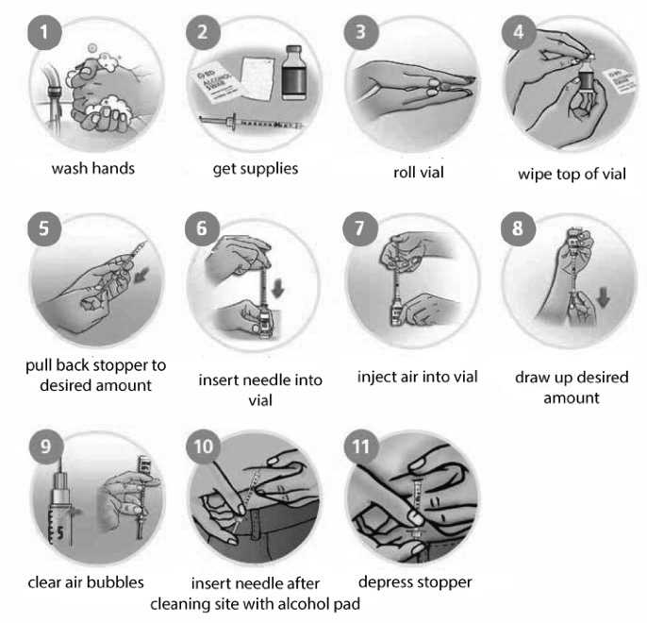
Self-Injection Routine ¹

Epi-pen Instructions ²

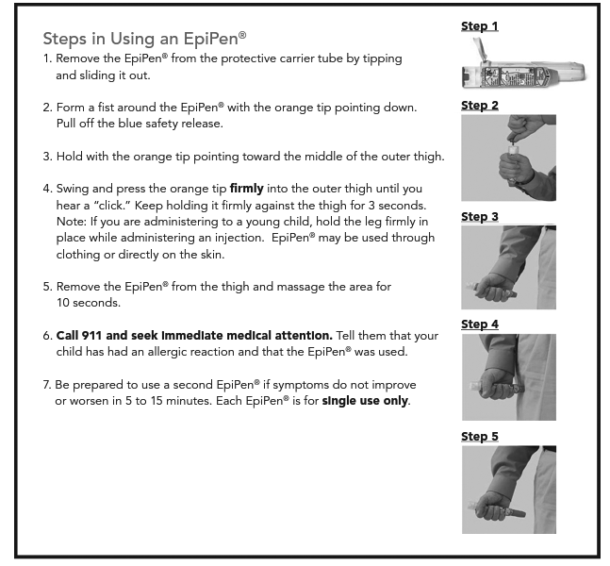
This handout is for general information only. The information and above list are guidelines and do not include all symptoms. This document is not a substitute for being seen by a doctor. Always call your doctor if you have questions or seek emergency medical attention if necessary.

Sources:
1. https://www.bd.com/resource.aspx?IDX=11020&CMP=PIG
2. https://www.stlouischildrens.org/sites/default/files/pdfs/FAME-Epipen-instructions.pdf

